Problem Statement

Product Dissection for top leading Platforms

Welcome to this case study on dissecting and designing products for top leading platforms. In this case study, you will delve into the intriguing world of schema design for a prominent platform of your choice. Your task is to choose a top leading platform, research its features, and meticulously craft a schema design that encapsulates the essence of its functionality. By focusing on key entities, attributes, and relationships, you will gain invaluable insights into how data architecture drives the platform's effectiveness.

Step 1: Choose a Leading Platform
Select a leading platform of your choice, which could span various domains such as social media, e-commerce, finance, or any other industry. This choice will form the foundation of your exploration into its schema design.

Step 2: Research:
Thoroughly research the platform you have selected. Investigate its core features, functionalities, and user interactions. Identify the top features that define its user experience and contribute significantly to its popularity.

Step 3: Product Dissection and Real-World Problems solved by the platform
In this step, you will meticulously analyse the platform's standout features and how they provide innovative solutions to real-world challenges. By identifying key functionalities that resonate with users, you'll unravel how the platform effectively addresses problems and enhances user experiences. This dissection will serve as the foundation for understanding how the schema design aligns with the platform's core objectives.

Step 4: Case Study on the real-world problems and approach to solving them
In this pivotal step, you will expand on the real-world challenges uncovered in Step 3 through a comprehensive case study. Delve into specific instances where users encountered difficulties and showcase how the platform's unique features provided effective solutions. By dissecting the approach taken by the platform to overcome these challenges, you'll gain a deeper appreciation for the platform's user-centric design philosophy and how it shapes the schema design.

Step 5: Schema Design Based on Top Features
Based on the features you have identified, craft a schema design that reflects the platform's data structure. Focus on the key entities, attributes, and relationships that underpin the chosen features. Your schema should capture the essence of how the platform organises and utilises its data.

Step 6: Rationale Behind the Design
While creating the schema design, consider the rationale behind the platform's choices. Reflect on why certain entities and relationships were chosen and how they align with the platform's goals. This will help you understand the strategic decisions driving the schema's architecture.

Step 7: Create an ER Diagram
Utilise tools like the Miro platform or similar applications to create an illustrative Entity-Relationship (ER) diagram. This diagram should vividly depict the entities, attributes, and relationships present within your schema design. The ER diagram will serve as a visual representation of your insights.

Step 8: Presentation of Findings
Present your findings in a clear and concise manner. Showcase your understanding of how the schema design impacts the platform's functionality and user experience. Explain how your chosen features are integrated into the schema and how the schema's structure supports the platform's objectives.

Task Details:

- Answer Submission: Your submission should include well-structured solutions for all provided questions related to product schema designs.

- Video Creation: Create an informative and engaging video where you thoroughly explain the Case Study.

- Depth and Clarity: Ensure your solutions are detailed and showcase your understanding of product schema design principles. Similarly, in the video, provide clear explanations that are easy to understand for a wide audience.

- Creativity Encouraged: You are welcome to utilise visuals, diagrams, or creative elements to enhance the clarity and impact of your explanations.

Note:
- Duplicate this document and proceed to write your solutions and prepare your video.
- Include the video link in this document before final submission.

Best of luck in completing this project and showcasing your prowess in dissecting and designing product schema for leading platforms! For reference, we have also conducted a case study on Instagram, which you can find below. This case study will provide you with valuable insights into how schema design plays a pivotal role in shaping the functionality and success of a prominent platform.


Product Dissection for Meesho

Company Overview:

Meesho, founded in 2015 by Vidit Aatrey and Sanjeev Barnwal, is a revolutionary social commerce platform that has redefined e-commerce for "Bharat" (Tier-2, Tier-3, and rural India). Originally a tool for resellers to sell on WhatsApp and Facebook, Meesho has evolved into a mass-market marketplace. It empowers small businesses and individual entrepreneurs—primarily women—to start their online businesses with zero investment. By 2025, Meesho has emerged as a leader in value-driven commerce, challenging major players with its 0% commission model and deep penetration into the Indian heartland.

Product Dissection and Real-World Problems Solved by Meesho:

Meesho has effectively addressed significant barriers to entrepreneurship and online shopping in India through its innovative platform.

Case Study: Real-World Problems and Meesho's Innovative Solutions

Meesho, India's fastest-growing social commerce platform, has not only revolutionised the way value-seeking consumers shop but has also addressed significant socio-economic challenges through its innovative features. By identifying the unique needs of the "Bharat" market (Tier-2+ cities) and leveraging a mobile-first technology stack, Meesho has positioned itself as a solution-driven platform that fosters micro-entrepreneurship, encourages financial independence, and democratizes e-commerce.

Problem 1: High Entry Barriers for Small Entrepreneurs

Real-World Challenge: Starting a retail business traditionally requires heavy capital for inventory, shop space, and marketing, making it inaccessible for millions (especially homemakers and students).

Meesho's Solution: By providing a Zero-Investment model, Meesho allows resellers to share products from suppliers directly on social media (WhatsApp, Facebook). The platform handles logistics and payments, empowering users to become entrepreneurs without financial risk.

Problem 2: Trust Deficit in E-commerce
Real-World Challenge: Many consumers in smaller towns are sceptical of buying from faceless online corporations.

Meesho's Solution: Leveraging social commerce. When a consumer buys through a friend or relative (a reseller), the inherent trust in that personal relationship bridges the gap between digital interaction and a genuine purchase, encouraging first-time online shoppers to join the ecosystem.

Problem 3: Information Overload and Content Discovery
Real-World Challenge: The sheer volume of online goods makes it difficult for value-conscious buyers to find affordable, relevant fashion and home decor.

Meesho's Solution: Through its curated catalogs and personalized recommendations, Meesho simplifies discovery. The app organizes products into easy-to-browse categories, helping resellers find items that specifically appeal to their local community's tastes.

Problem 4: Information Overload & Discovery in Value Shopping
Real-World Challenge: Large e-commerce platforms often prioritize big brands, making it difficult for budget-conscious consumers to find unbranded, high-quality, and affordable "value" products tailored to regional tastes.

Meesho's Solution: Meesho's curated "Explore" and "Community" features use data-driven algorithms to suggest trending, high-value items based on regional preferences. By categorizing products into niche catalogues that are easily "shareable," Meesho solves the problem of discovery. Users don't have to sift through millions of irrelevant items; they see what is trending in their specific social or regional circles.

Conclusion:
Meesho's journey from a localized reselling tool to a national marketplace is a testament to its ability to identify deep-seated structural problems in the Indian economy and provide tech-enabled solutions. By fostering financial independence for women, building trust through social networks, and simplifying logistics for small suppliers, Meesho has reshaped the digital landscape for the next billion users.

Top Features of Meesho:

- Reseller Catalogs: A vast collection of products that can be shared instantly with custom profit margins.

- Meesho Community: A space for entrepreneurs to learn, share success stories, and gain business insights.

- Integrated Logistics: A seamless system that manages pickup from suppliers and delivery to the end customer.

- User Profiles: Separate dashboards for resellers to track their earnings, margins, and customer orders.

- Search & Filters: Optimized tools to find niche products across diverse categories like ethnic wear, electronics, and home utilities.

Meesho Schema Description:
The database schema for Meesho involves entities representing the marketplace dynamics between Suppliers, Resellers, and Customers.

1. User Entity (Multi-Role)
Users are the backbone of Meesho. A user can be a Reseller, a Customer, or both.

UserID (PK): Unique identifier for each user.

Username: Account handle.

Email/Phone: Contact for OTP verification and order updates.

User_Type: Identifies if the user is primarily a Reseller or Customer.

Registration_Date: When the user joined the platform.

2. Product Entity
Captures the items listed by suppliers.

ProductID (PK): Unique identifier for each product.

SupplierID (FK): References the supplier providing the item.

Price: The base cost of the product.

Image_URL: Links to the product visuals.

Category: The grouping (e.g., "Sarees," "Kitchen Tools").

3. Order Entity
Manages the transaction between all three parties.

OrderID (PK): Unique identifier for the transaction.

CustomerID (FK): The end-user receiving the product.

ResellerID (FK): The entrepreneur who facilitated the sale.

Total_Price: Base price + Reseller margin.
Order_Status: Tracking (Pending, Shipped, Delivered).

4. Shared_Product Entity (Interaction)
Tracks social commerce engagement.

ShareID (PK): Unique ID for a "share" action.

ResellerID (FK): The user sharing the item.

ProductID (FK): The item being shared.

Platform: Where it was shared (WhatsApp, Facebook).

ER Diagram:

Let's construct an ER diagram that vividly portrays the relationships and attributes of the entities within the Meesho schema. This ER diagram will serve as a visual representation, shedding light on the pivotal components of Meesho's data model. By employing this diagram, you'll gain a clearer grasp of the intricate interactions and connections that define the platform's dynamics.
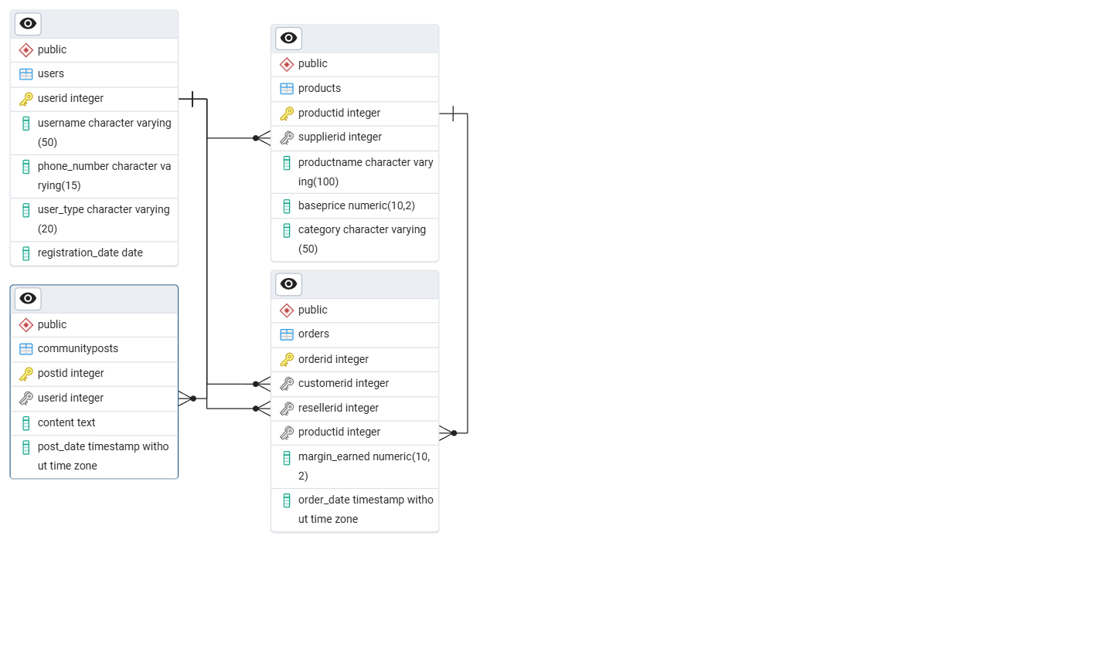

Conclusion :
Meesho’s schema is designed to handle the complexity of three-way transactions (Supplier-Reseller-Customer). By prioritizing a user-centric data model, Meesho effectively manages the lifecycle of a product from a small supplier’s warehouse to a customer's doorstep, all while enabling a local entrepreneur to earn a livelihood.
Meesho's transition from a simple reselling tool to a massive e-commerce ecosystem demonstrates the power of solving for "unserved" markets. By removing financial risk for entrepreneurs and building a logistics backbone for small suppliers, Meesho hasn't just built an app; it has built a digital economy for millions of Indians.

Video Explaination link :

